|  |  |  |
| --- | --- | --- |
| **UNIVERSITAS PEMBANGUNAN NASIONAL “VETERAN” JAKARTA**  **FAKULTAS ILMU SOSIAL DAN ILMU POLITIK** | NAMA : _________________________  NIM : _________________________ |  |
|  |  |  |

**E-learning Semester Genap TA. 2018/2019**

MATA KULIAH : Bahasa Inggris II

HARI/TANGGAL : Jum’at / 8 November 2019

WAKTU : 08.00 – 17.00

JURUSAN : SI-Hubungan Internasional

DOSEN : Arjulayana,SS.,M.Pd

1. **READING**

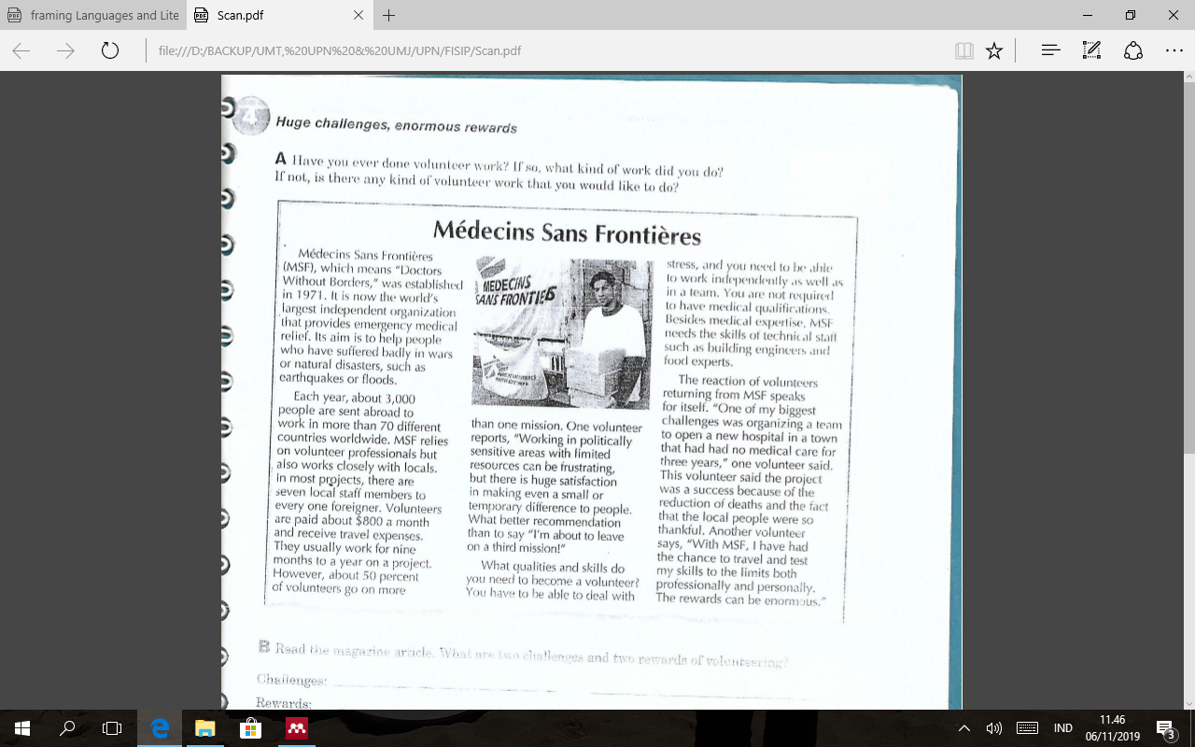

**Answer these questions!**

1. What is the aim of Medicine Sans Frontieres?
2. How many countries receive foreign volunteers through MSF?
3. What personal qualities must volunteers have?
4. What kinds of experts does MSF requires?
5. Mention the challanges of volunteering based on the article!
6. What are two rewarding of volunteering in that article?
7. What is the average ratio of local staff members to foreign volunteers?
8. “It” in paragraph1, line 2, means?
9. How long does volunteer usually works in one project?
10. Does the volunteers are paid? How much they will receive?
11. **Change these sentences into passive** *( is/are + past particple or modal + be + past participle***) form**
12. The smart student followed political debate in the University festival program
13. The head study program of International relation announced the new rule without formality setting
14. Many anttendeces came late in the official celebration last night
15. Students are presenting their mini research regarding to economic and poitical issues
16. The test taker were taking some notes for indicipline examination time
17. The painter paints the school building to face the great event in this year
18. By the middle of twenties century, scientist discovered a way to prevent aging
19. Phytecean thropus erectus is one of the history which should be keep in a great place
20. The editor and marketer of under cover book translated well and promoted it in foriegn country
21. Sania has been living in Bali for almost 25 years
22. Write a job that you interested in. In the first paragraph you need to decribe the job, what you call that job and why you would like to have it. In the second paragraph describe what things should be involved to support the job, in the third paragraph decribe how that job must be promoted and suitable with your passion and in the last paragraph you need to conclude your writing about the job you interested in. Use passive form in some of your descriptions.
23. Write the sequence of designing a new film in 3 paragraph